Paper size: 8½ x 11”
Total length: 4 pages
Margins: 1” top and bottom, 0.75” left and right
9 point Times New Roman
Two Columns
14 point Times New Roman font, no bold or italic, centered, capitalize main words

Evaluation of Circularity and Sphericity from Coordinate Measurement Data
10 point Times New Roman,
bold on Author Name, centered
G.L.Samuel and M.S.Shunmugam*
Manufacturing Engineering Section, Department of Mechanical Engineering
Indian Institute of Technology, Chennai - 600 036, INDIA
___________________________________________________________________________________
Abstract
The Coordinate Measuring Machines (CMMs) have proven to be reliable, flexible and very much suitable for determining the acceptability of manufactured parts. In this paper, techniques for evaluating circularity and sphericity error from CMM data are presented. The form error can be evaluated directly from CMM data by employing circle/sphere as assessment features and using normal deviations. The CMM data can also be transformed by applying appropriate methods that not only suppress the size but also introduce distortion. The form error is evaluated from the transformed data by employing limacon/limacoid as assessment features and using linear deviations. The methods for handling CMM and transformed data are given in this paper. The proposed methods are validated using the data available in literature.
Keywords: Circularity Error, Sphericity Error, Coordinate Measurement data.
______________________________________________________________________________________________________________
Level 1 headline: 9 point Times New Roman
Bold, ALL CAPS

- INTRODUCTION
In the present day advanced manufacturing scenario, the components produced must strictly adhere to the dimensional, positional and form specifications, in order to have an edge over competitor’s products. The manufactured components have to be inspected to ensure that the geometric form of the components is conforming to the design specifications. The Computer Aided Inspection (CAI) procedures have gained a prominent role in the field of inspection and evaluation of the manufactured parts. In the recent years, the Coordinate Measuring Machines (CMMs) have gained popularity in automated inspection for both on-line and off-line inspection of manufactured components. The data for evaluation of form errors obtained from CMM will be in cartesian coordinates given with reference to a system of mutually orthogonal planes and the data combines form and size aspects. This data has to be further processed using appropriate techniques to evaluate the form error.
The ANSI Dimensioning and Tolerance Standard Y14.5 [1] defines form tolerances of a component with reference to an ideal geometric feature and ISO standards [2] recommend the form to be evaluated based on the minimum zone concept. However, both these standards do not specify the methods by which the form has to be evaluated.
In order to obtain reliable results during the evaluation of circularity and sphericity error, the coordinate data obtained from the inspection devices such as Coordinate Measuring Machines (CMMs) have to be processed using appropriate techniques. It is important that these techniques follow the specifications laid down in the standards.
Few attempts have been made by previous researchers to develop methods for evaluating circularity and sphericity error.

Least Squares Method (LSM), that minimizes the sum of the squared deviations of the measured points from a fitted feature has been suggested [3]. Though the least squares techniques are based on sound mathematical principles, the error values obtained are not the minimum. The Normal Least Square fit has also been tried by Murthy and Abdin [4], but the values obtained are not the minimum. To obtain the minimum zone solution, the numerical methods based on Monte Carlo, Simplex and Spiral Search techniques [4,5] were also suggested. Shunmugam has suggested a new simple approach called the Median technique that gives minimum value of form error [3]. Using discrete Chebyshev approximations, Danish and Shunmugam have arrived at the minimum zone values [6]. A minimax approximation method for evaluation of roundness was used by Ventura and Yeralan [7]. A statistical technique for estimating the sphericity from a few 2-D roundness values was also proposed [8]. Theoretical derivation of the minimum zone criteria of sphericity error based on the principle of minimum potential energy was also proposed [9]. In recent years, computational geometry based assessment techniques for evaluation of roundness error based Voronoi diagram methods has also been tried [10,11]. In a different attempt, a Minimum Zone Center (MZC) based on the concept of Voronoi diagrams has been compared with Least Squares Center algorithm [12].
ISO 3290 dealing with rolling bearings, bearing parts and balls for rolling bearings, defines the deviation of spherical form as the greatest radial distance in any radial plane between a sphere circumscribing the ball surface and any point on the ball surface [13]. Generally, the ball profiles are obtained in two or three equatorial planes at 90⁰ to each other using roundness measuring instrument. The evaluation based on roundness measurements, namely two-dimensional measurements, is inadequate to arrive at the sphericity error that is three-dimensional in nature. For the evaluation of sphericity error, the concepts of form tolerances dealt in International Standard ISO 1101 have to be extended to cover spherical forms [1].
The coordinate data from CMM combines the information on form as well as size and a suitable transformation has to be employed to separate these two types of information. In this paper, appropriate methods have been presented to handle the two and three-dimensional coordinate data obtained from CMMs for circular and spherical features respectively. Methods to directly arrive at the error value using CMM data have been suggested. Also the transformations required for converting the CMM data for evaluation of circularity and sphericity errors are given. While evaluating the circularity error using CMM data directly a circle is considered as the assessment feature and while using the transformed data a limacon is considered. Similarly a sphere is used as assessment feature while evaluating the sphericity error using CMM data
Circularity error
Assessment features
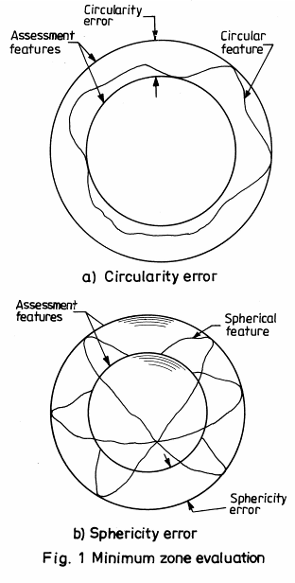
and a new surface named as limacoid is used while processing the transformed data. The techniques and results are discussed with numerical examples.
- CIRCULARITY AND SPHERICITY ERRORS
The International Standard ISO 1101 [1] defines circularity error as the radial distance between two concentric circles separated by minimum possible distance and containing all the measurement points on the given profile as shown in Fig. 1(a). However sphericity evaluation is to be done with reference to two concentric spheres containing all points of the data set and having the minimum separation as shown in Fig. 1(b).
For the purpose of assessment, it is convenient to think of an assessment feature superimposed in such a way that the maximum distance between it and the actual feature concerned is the least possible value. Once such an assessment feature is established, the circularity or sphericity error is evaluated with reference to these assessment features as
Equations, Justified, 9 point, Times New Roman, Italic
Error Δ= | e_{max} | + | e_{min} | (1)

Circular feature
where e_{max} and e_{min} are the maximum and minimum deviations of the data points from the assessment feature.
- EVALUATION FROM COORDINATE DATA
Level 2 headline: 9 point Times
New Roman Bold
3.1 Circularity Error
While evaluating the circularity error using coordinate data, the assessment circle is established with O₀'(x₀', y₀' ) as center and
Table 1
CMM Data of a Circular profile [16]
Fig 1. Title of figure, centered,
subsequent text Indented, Times New Roman 8, single line spacing
- Circularity error
Assessment features
Spherical feature
Sphericity error
b) Sphericity error
Fig. 1. Minimum zone evaluation
Sl. No. | x_{i} mm | y_{i} mm
1 | 70.0150 | 50.0000
2 | 68.7900 | 58.4734
3 | 65.4060 | 65.9372
4 | 59.5675 | 72.7493
5 | 51.3791 | 77.7452
6 | 44.7944 | 79.6013
7 | 40.8903 | 79.9958
8 | 32.0312 | 78.9306
9 | 27.2296 | 77.1385
10 | 20.3993 | 72.7076
11 | 16.1556 | 68.2304
12 | 12.7184 | 62.4905
13 | 10.6380 | 56.0806
14 | 10.0183 | 49.2149
15 | 11.4275 | 40.8264
16 | 14.1050 | 34.8682
17 | 18.8168 | 28.7427
18 | 24.6321 | 24.2200
19 | 31.6833 | 21.1862
20 | 39.1626 | 20.0207
21 | 45.5204 | 20.5021
22 | 55.3996 | 24.2692
23 | 62.3561 | 30.0114
24 | 67.3540 | 37.6492
25 | 69.6190 | 45.2028
radius r₀' as shown in Fig 2(a). The CMM data is shown in Table 1. The normal deviation of a point (x_{i}, y_{i}) on the profile from the assessment circle is determined as given below
e_{i}' = [(x_{i}-x₀' )² + (y_{i}-y₀' )²]^{1/2} -r₀' (2)
The circularity error is determined using the equation (1).
Level 3 headline: 9 point Times New Roman, Italic.
    - Sphericity Error
While evaluating the sphericity error, the normal deviation of a point from the assessment sphere with center O₀' (x₀', y₀', z₀' ) and radius r₀' as shown in Fig. 2(b) is considered. CMM sphericity data is shown in Table 2. The normal deviation is given by
e_{i}' = [(x_{i}-x₀' )² + (y_{i}-y₀' )²+ (z_{i}-z₀' )²]^{1/2} - r₀' (3)

- TRANSFORMATION OF COORDINATE DATA
  - Circularity Data
The coordinate measurement data can be transformed with respect to a reference circle. The reference circle with center O_{R} (x_{R}, y_{R}) and radius r_{R} is established by selecting three points R₁, R₂ and R₃, from the given data set as shown in Fig. 3(a). The deviations of a point from the reference circle is given by
- Circularity error
d_{i} = [ (x_{R} - x_{R})² + (y_{R} - y_{R})² ]^{1/2} - r_{R} (4)
Assessment limacoid
The transformed data is represented in the polar coordinates as
r_{i} = d_{i} - d_{min} + d₀ (5)
θ_{i} = tan⁻¹[ (y_{i}-y_{R}) / (x_{i}-x_{R}) ] (6)
where d_{min} represents minimum of d_{i} values and d₀ is chosen conveniently say 0.01 mm. The transformed data is shown in Table 3.
  - Sphericity Data
A sphere passing through four points of the data set can be established as shown in Fig. 3(b). The deviation of each data point from the reference sphere is determined by
b) Sphericity error
Fig. 4. Assessment using transformed data
d_{i} = [ (x_{i} - x_{R} )² + (y_{i} - y_{R})² + (z_{i} - z_{R})² ]^{1/2} - r_{R} (7)
The transformed data is given in the spherical coordinates as
r_{i} = d_{i} - d_{min} + d₀ (8)
θ_{i} = tan⁻¹[ (y_{i}-y_{R}) / (x_{i}-x_{R}) ] (9)
β_{i} = tan⁻¹[ (z_{i}-z_{R}) / (x_{i}-x_{R}) ] (10)
where (r_{i}, θ_{i}, β_{i} ) represents the point in the polar form, d_{min} is the minimum of d_{i} values and d₀ is chosen conveniently. The transformed data is shown in Table 4.
- EVALUATION USING TRANSFORMED DATA
  - Circularity Error
As the transformation is done with respect to a selected canter, the profile gets distorted and the resultant profile can be well approximated to a limacon [15]. The deviation of a point (r_{i}, θ_{i}) is expressed with reference to the limacon as (Ref. Fig. 4(a))
e_{i} = r_{i} - [r₀ + x₀ cosθ _{i} + y₀ sinθ_{i}] (11)
where O₀ (x₀, y₀) is the center and r₀ is the radius of the circle from which the limacon is obtained [14]. e_{i} in Equation (11) is referred to as linear deviation.
Assessment limacon
ρ_{i} (r_{i}, θ_{i})
ρ_{i} (r_{i}, θ_{i,} β_{i})
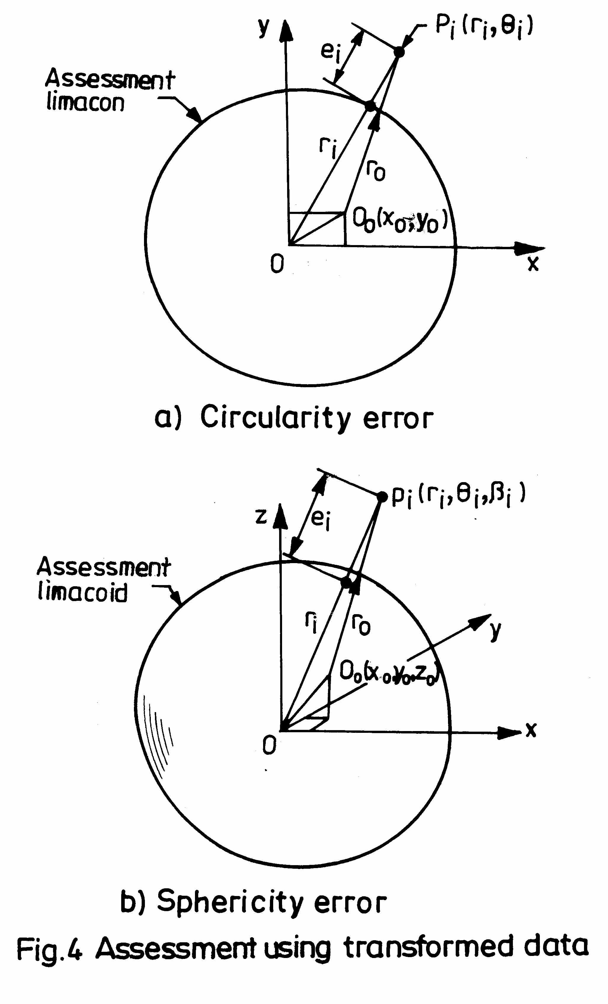
- RESULTS AND DISCUSSION
The Data Sets in Table 1 and 2 shows the CMM data for circularity and sphericity features respectively. The Data sets in Table 3 and 4 are the data obtained by applying appropriate transformations on the CMM data sets given in Table 1 and 2 respectively. These data sets are taken to bring out the differences in approaches to be followed for processing CMM data and transformed data. Table 5 shows the results of minimum zone evaluation of circularity and sphericity. Various parameters of the assessment feature such as the coordinates of the center and radius are also given in Table 5. The simplex search techniques suggested by Shunmugam have been used in the present work for evaluating the circularity and sphericity errors [14].
Table, 9 point Times New Roman, Horizontal borders, align center

Table 5: MZ Evaluation of Circularity and Sphericity
Sl. No | Reported Method |  |  | Present Approach
Sl. No |  |  |  | Without Transformation |  | With Transformation
 | Form Error | Parameters (mm) | Form Error (μm) | Parameters (mm) | Form Error (μm) | Parameters (μm) | Form Error (μm)
1 | Circularity | x₀=40.0008[16]  y₀=50.0016[16]  r₀=30.0001[16] | 29.2860[16] | x₀'=40.0007  y₀'=50.0015  r₀'=30.0000 | 29.2816 | x₀=-5.9602  y₀=10.6228  r₀=34.2762 | 29.2809
2 | Sphericity | - | 7.660[9] | x₀'=0.0025  y₀'=-0.0001  z₀'=0.0005  r₀'=1.00543 | 7.66023 | x₀=1.1181  y₀=0.4149  z₀=-0.1726  r₀=5.3717 | 7.66011

Also these values are well in agreement with the error values published in the literature. The form error value for the CMM data is based on the normal deviations, whereas for the transformed data it is based on linear deviations. However there is a small difference in the form error values obtained, due to the approximation error which is negligibly small. The use of normal deviation for the transformed data will lead to incorrect results and hence should be avoided.
7 CONCLUSIONS
The CMM data contains both size and form information and hence circle/sphere is used as assessment feature and the normal deviations are to be considered. The coordinate measurement data can be converted suitably by applying appropriate transformations and it can be further processed to evaluate the form errors. As the size is suppressed and the profile is distorted while transforming, limacon/limacoid is used as assessment feature and linear deviations are to be considered. By applying appropriate methods, the value of form error remains the same for a particular profile whether the coordinate data (CMM data) or the transformed data is used for processing. It is to be mentioned here that the transformed data represents the data obtained using form measuring instruments and the method suggested in this paper can be used directly for the data obtained from these instruments.
[1] Authors., “Paper title,” Journal name, Volume: Page no(s), Year.
References
- Dimensioning and Tolerancing, ANSI Standard Y14.5, The American Society of Mechanical Engineers, New York, 1982.
- Technical drawings - Geometrical Tolerancing, ISO 1101, (1983)12-01.
- Shunmugam M.S., On assessment of geometric errors, International Journal of Production Research, 24 (1986) 413-425.
- Murthy T. S. R. and Abdin S. Z., Minimum zone evaluation of surfaces, International Journal of Machine tool Design and Research, 20 (1980) 123-136.
- T. Kanada, Evaluation of spherical form errors – Computation of sphericity by means of minimum zone method and some examinations with using simulated data, Precision Engineering, 17 (1995) 281 – 289.
[2] Authors., “Book title, Publisher’s name, State, Country, Volume: Page no(s), Year.
- Danish. P. B. and Shunmugam. M. S., An algorithm for form error evaluation using the theory of discrete and linear Chebyshev approximations, Computer Methods in Applied Mechanics and Engineering, 92 (1991) 309-324.
- J.A. Ventura, S. Yeralan, The minimax center estimation problem for automated roundness inspection, European Journal of Operations Research, 41 (1989) 64-72.
- T. Kanada, Estimation of sphericity by means of statistical processing for roundness of spherical parts, Precision Engineering, , 20 (1997) 117 – 122.
- K.C. Fan, J.C. Lee, Analysis of minimum zone sphericity error using minimum potential energy theory, Precision Engineering, 23 (1999) 65-72.
- Roy U.R. and Zhang X., Establishment of a pair of concentric circles with the minimum radial separation for assessing roundness error, Computer-Aided Design, 24 (1992) 161-168.
- Roy U.R. and Zhang X., Development and application of voronoi diagrams in the assessment of roundness error in an industrial environment, Computers in Industrial Engineering, 26 (1994) 11-26.
- Novasaki O. and Barczak A. L. C., Utilization of voronoi diagrams for circularity algorithms, Precision Engineering, 20 (1997) 188-195.
- ISO 3290 Rolling Bearings – Bearing parts – balls for rolling bearings (1975) E.
- Shunmugam. M. S., Comparison of linear and normal deviations of form of engineering surfaces, Precision Engineering, 9 (1987) 96-102.
- G.L. Samuel and M.S. Shunmugam, Evaluation of Circularity from Coordinate and Form data using Computational Geometric Techniques, Accepted for publication in Precision Engineering.
- Namboothiri V. N. N., Development of algorithms and strategies for the evaluation of engineering surfaces, Ph. D Thesis, Indian Institute of Technology, Madras, India, 1998.
- G.L. Samuel and M.S. Shunmugam, Use of Limacon and Limacoid in Evaluation of Circularity and Sphericity Errors, To be published in All India Manufacturing Technology Design and Research Conference, Chennai, India, Dec. 2000.
[3] Authors., “Paper title,” in Edited book, editor(s), State, Country, Volume: Page no(s), Year.

*Author to whom correspondence should be made, Email: shun@acer.iitm.ernet.in

